Title:-Write a C++ program to define a class “Employee” having data members emp_no, emp_nam and emp_designation. Derive a class “Salary” from “Employee” having data members basic, hra, da, gross_sal. Accept and display data for one employee.
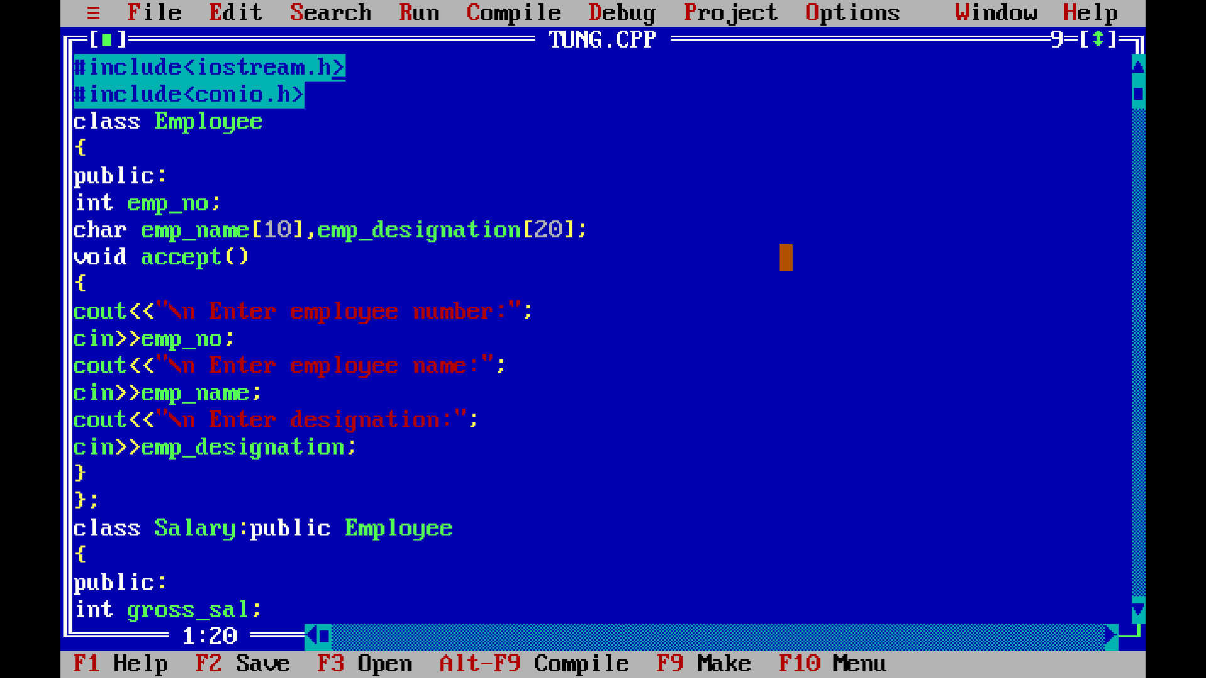

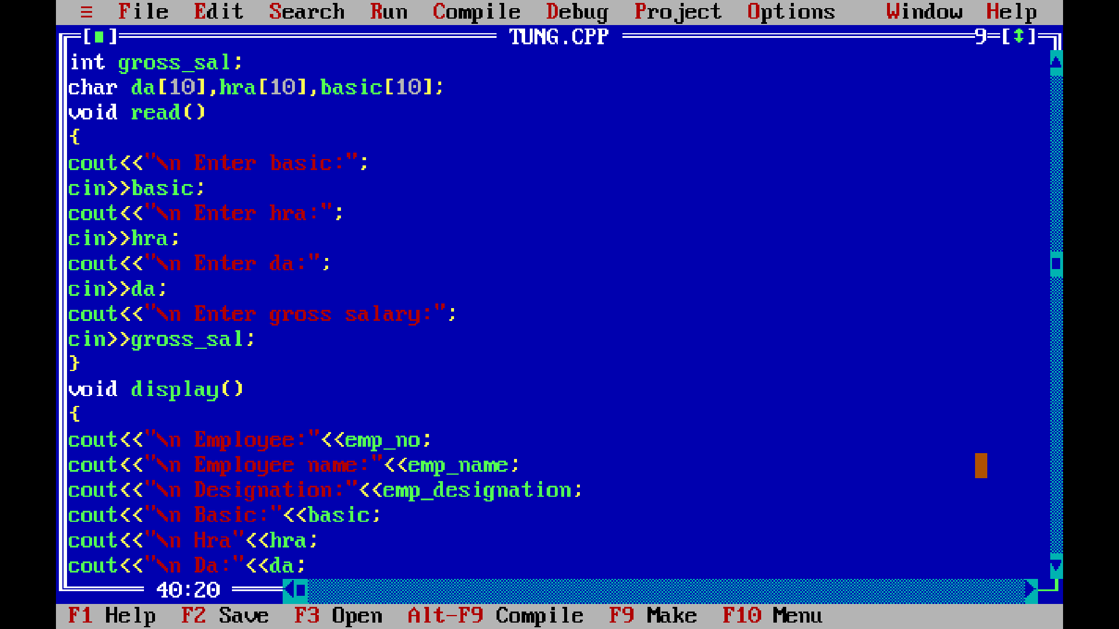
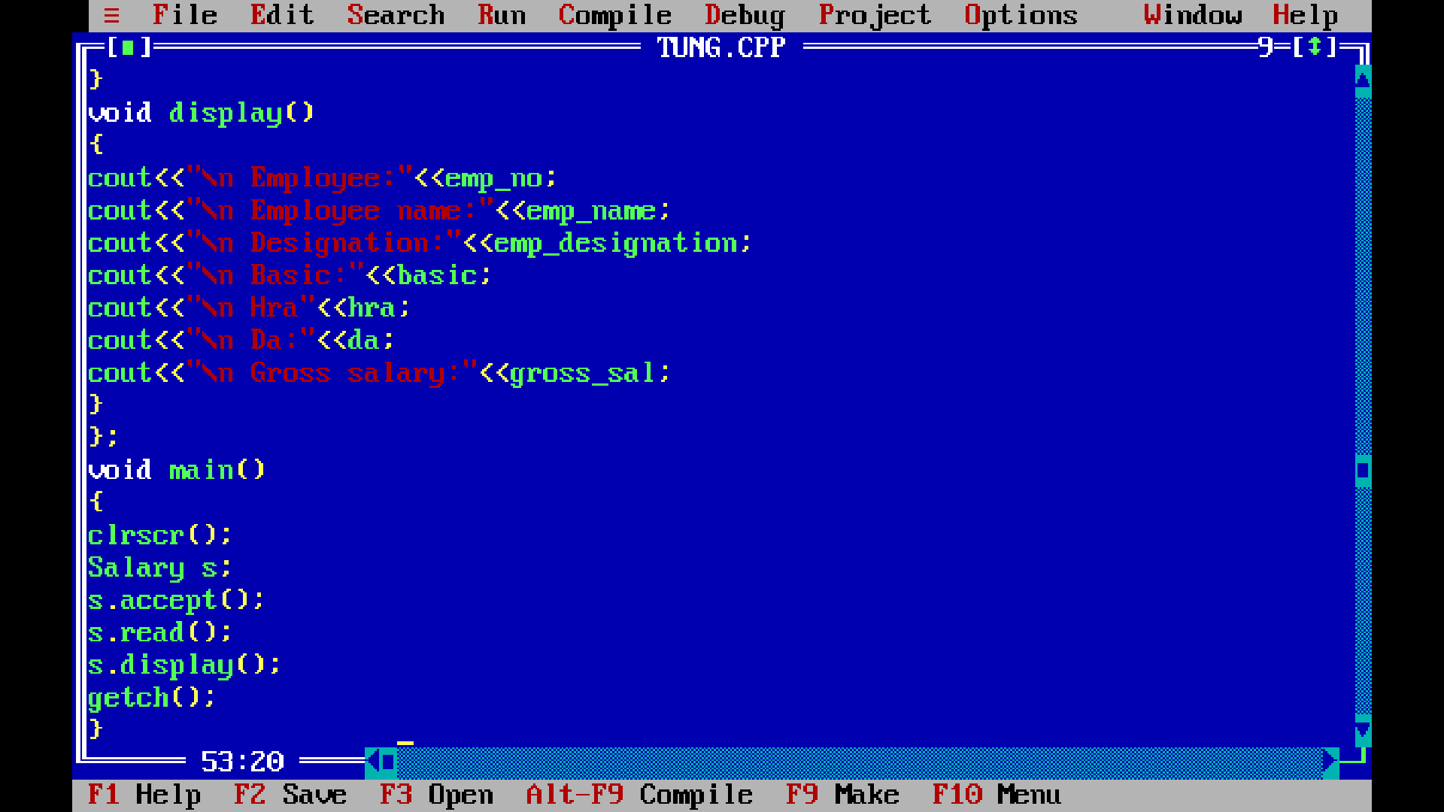
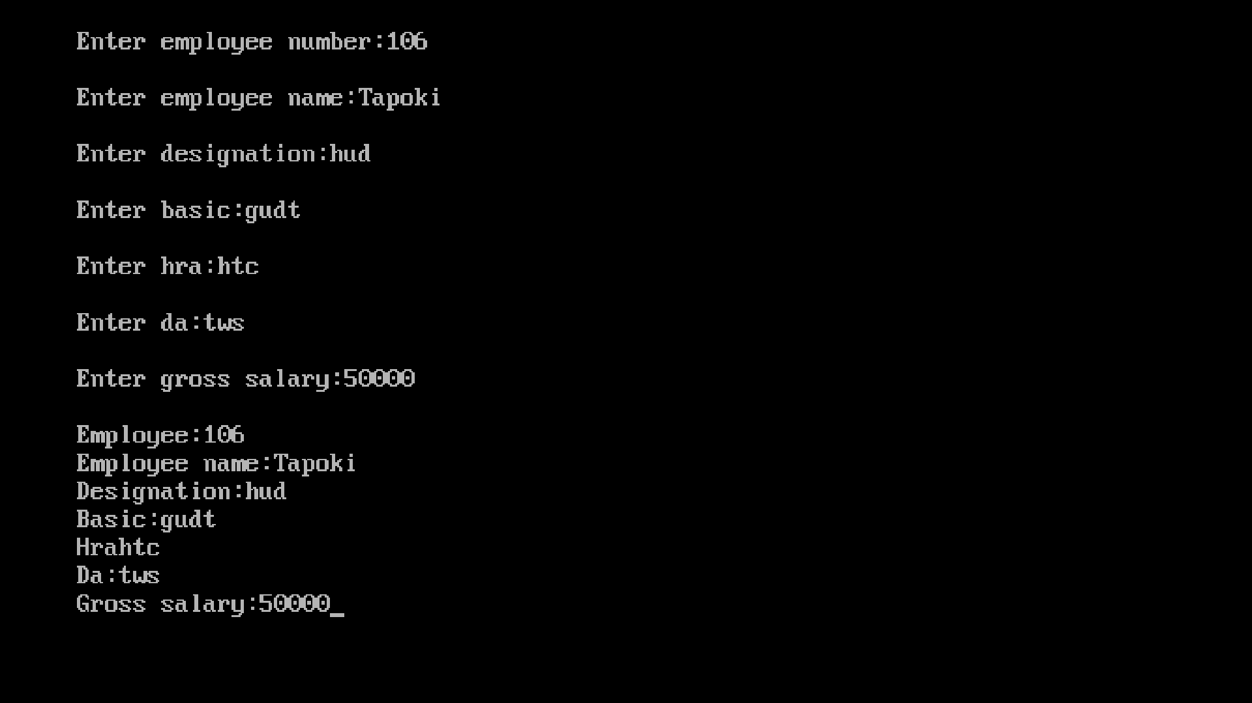

Title:-WAP to implement default constructor that initializes num1 and num2 as 10 amd 20 prints the values of num1 and num2.

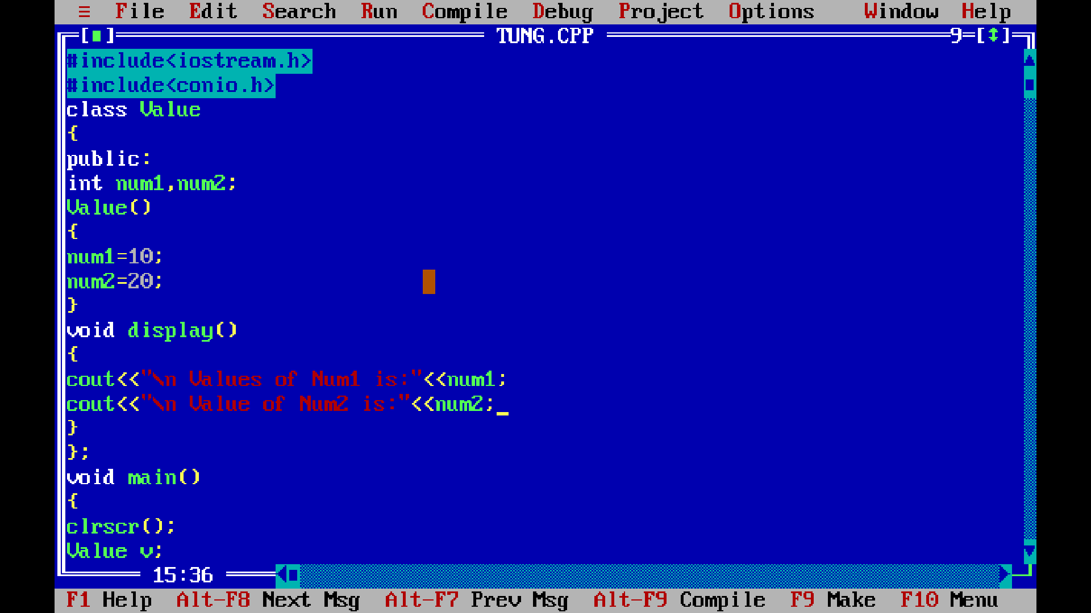

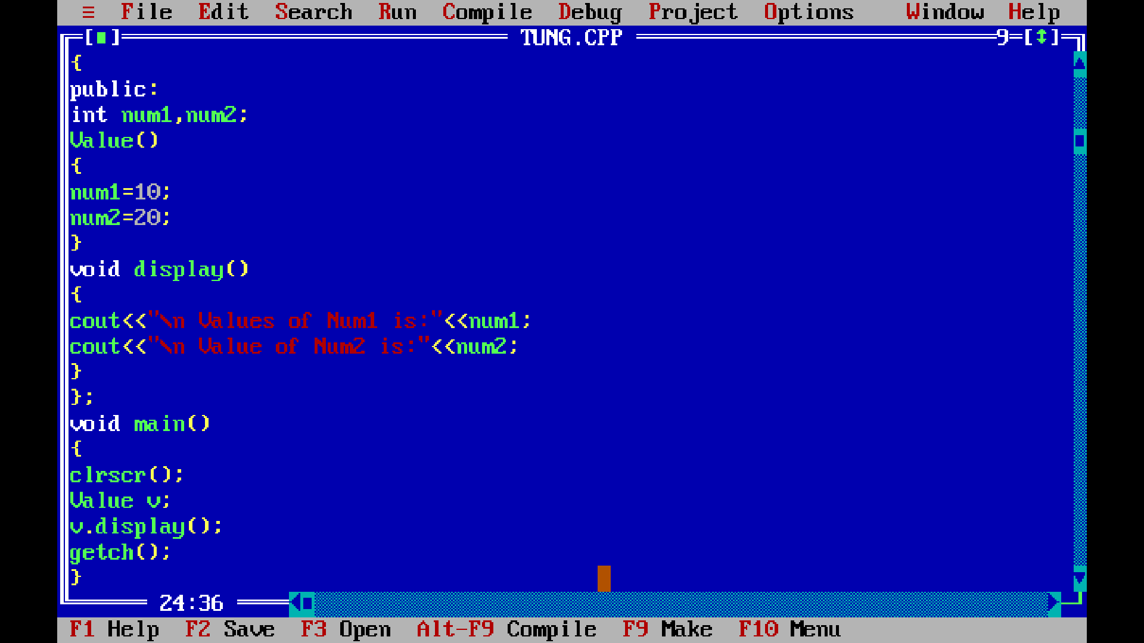

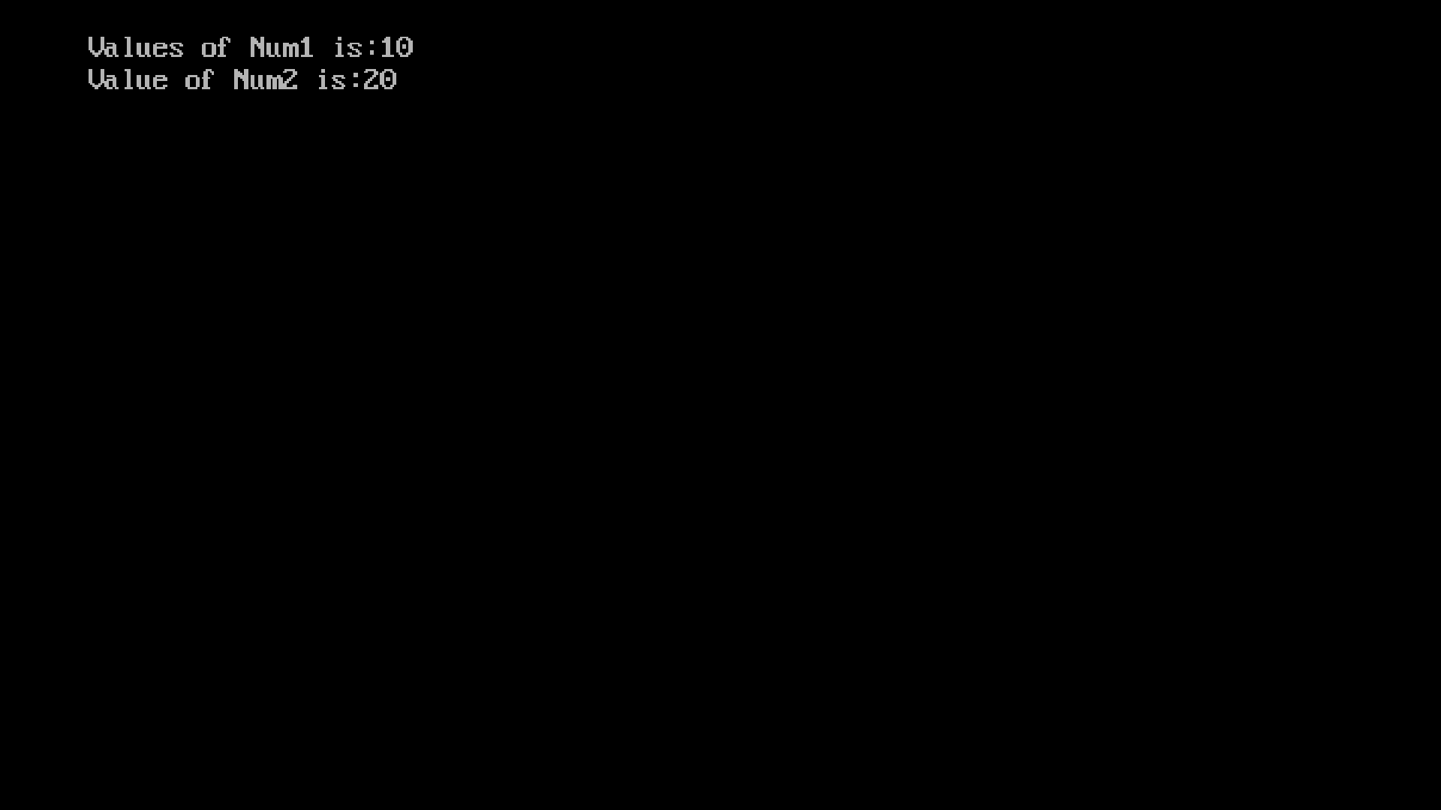

Title:- Write C++ program to declare class ‘Account’ having data members as Account_No and balance. Accept this data for 10 accounts and display data of Accounts having balance greater than 10000.

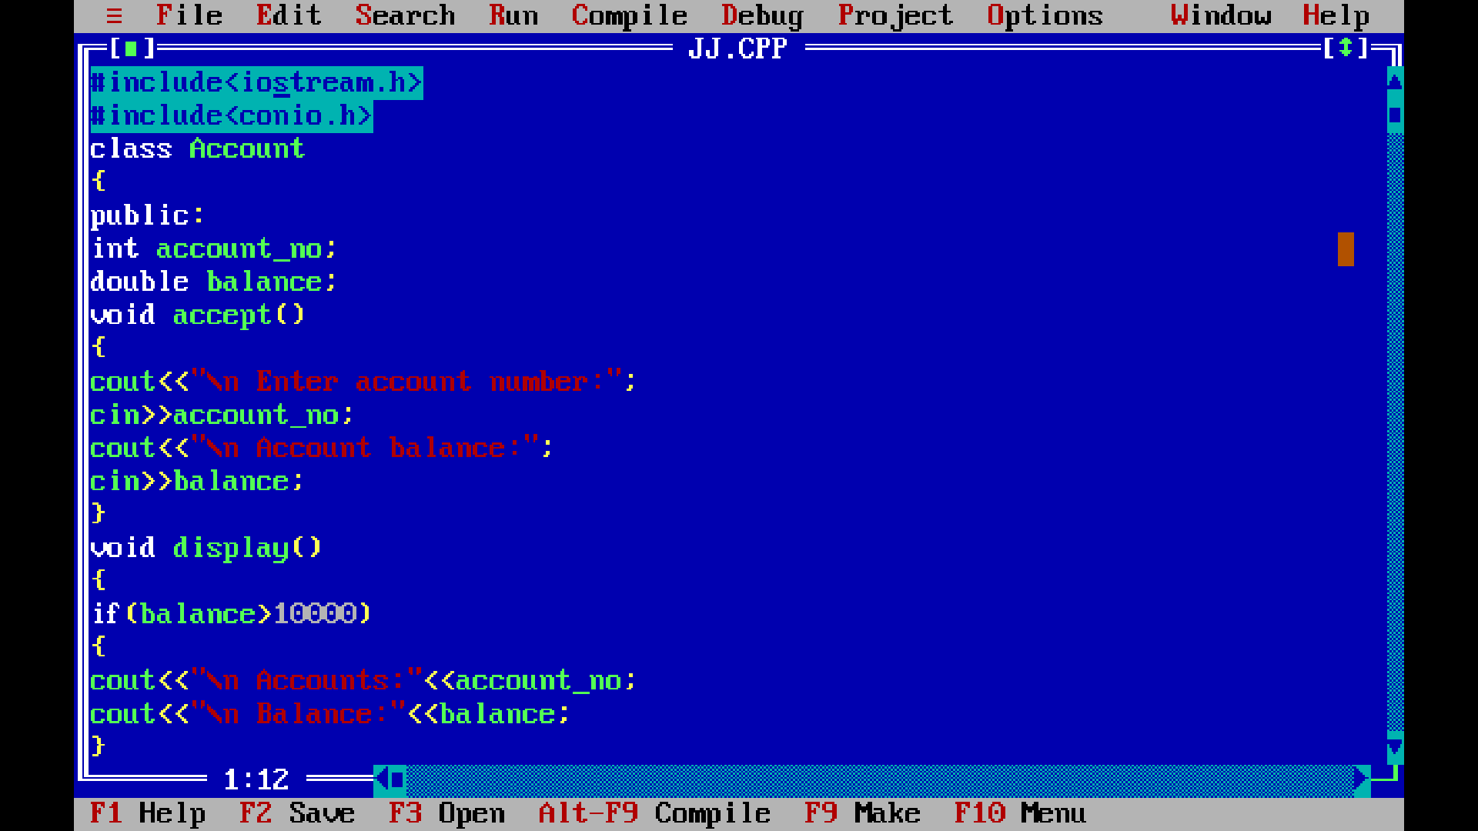

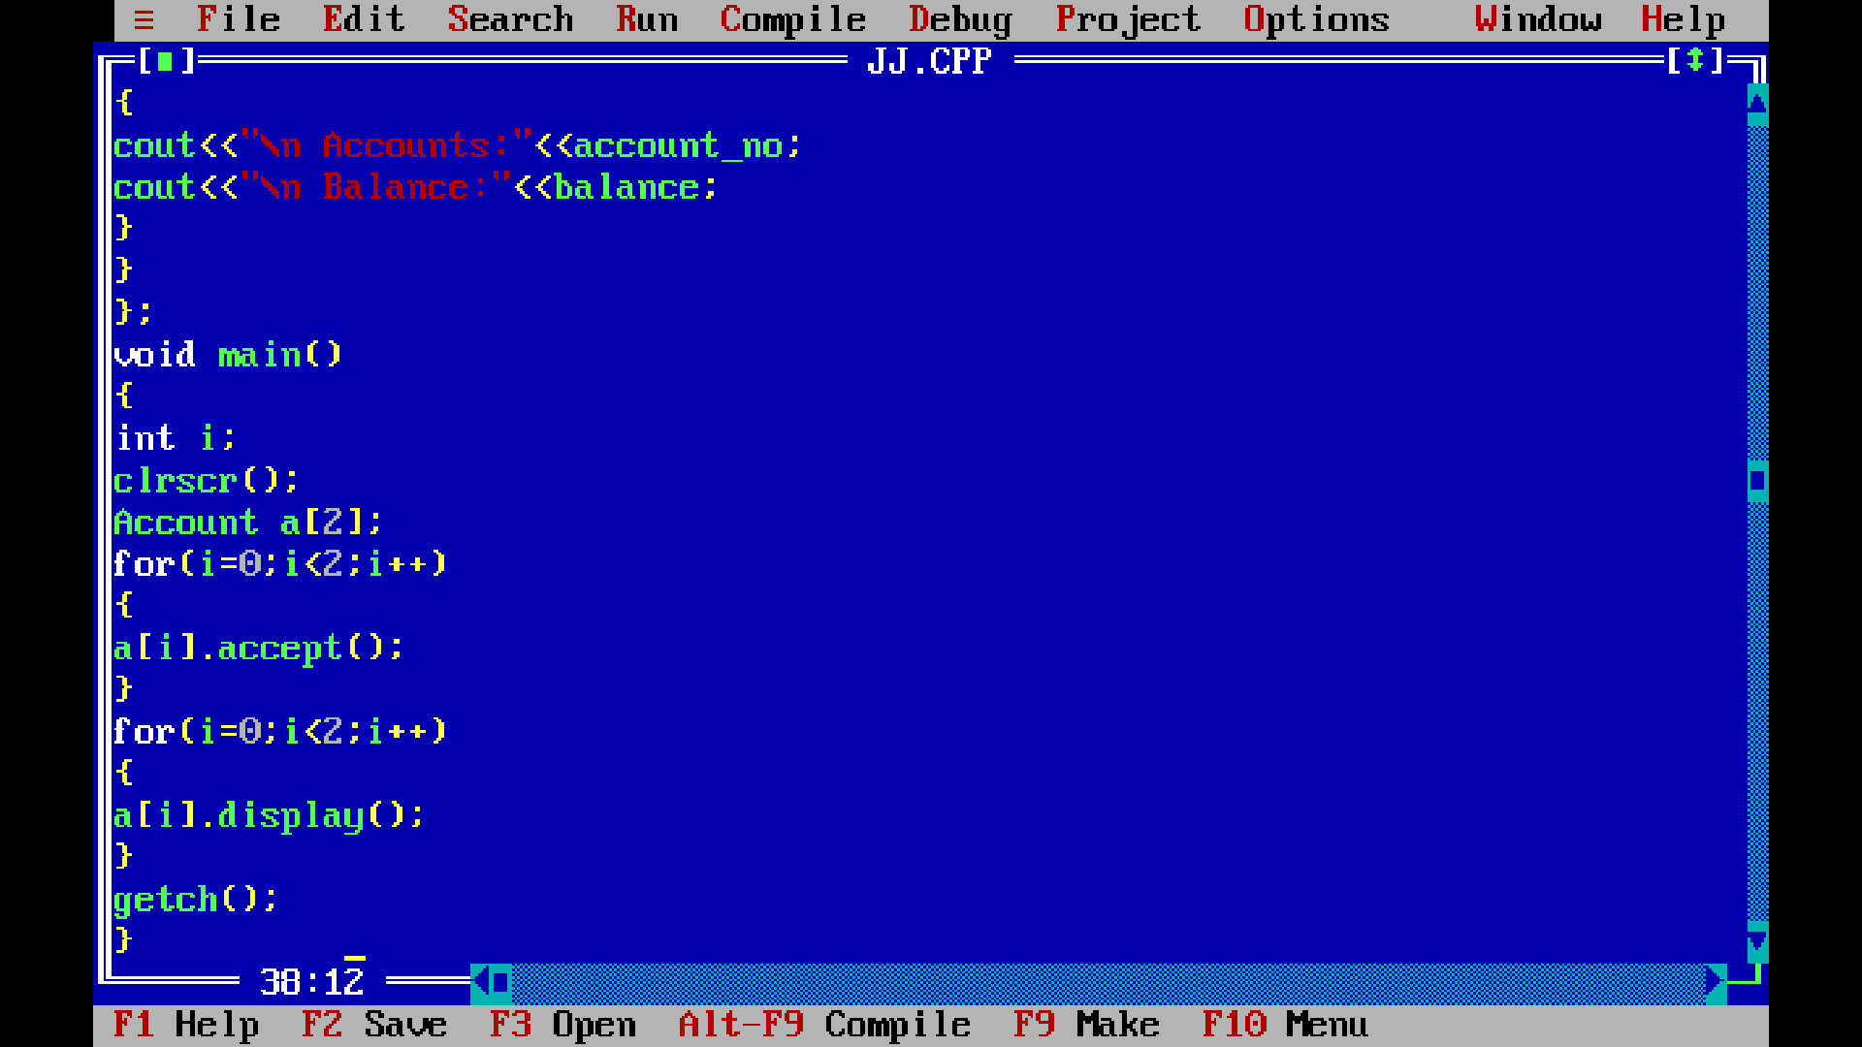
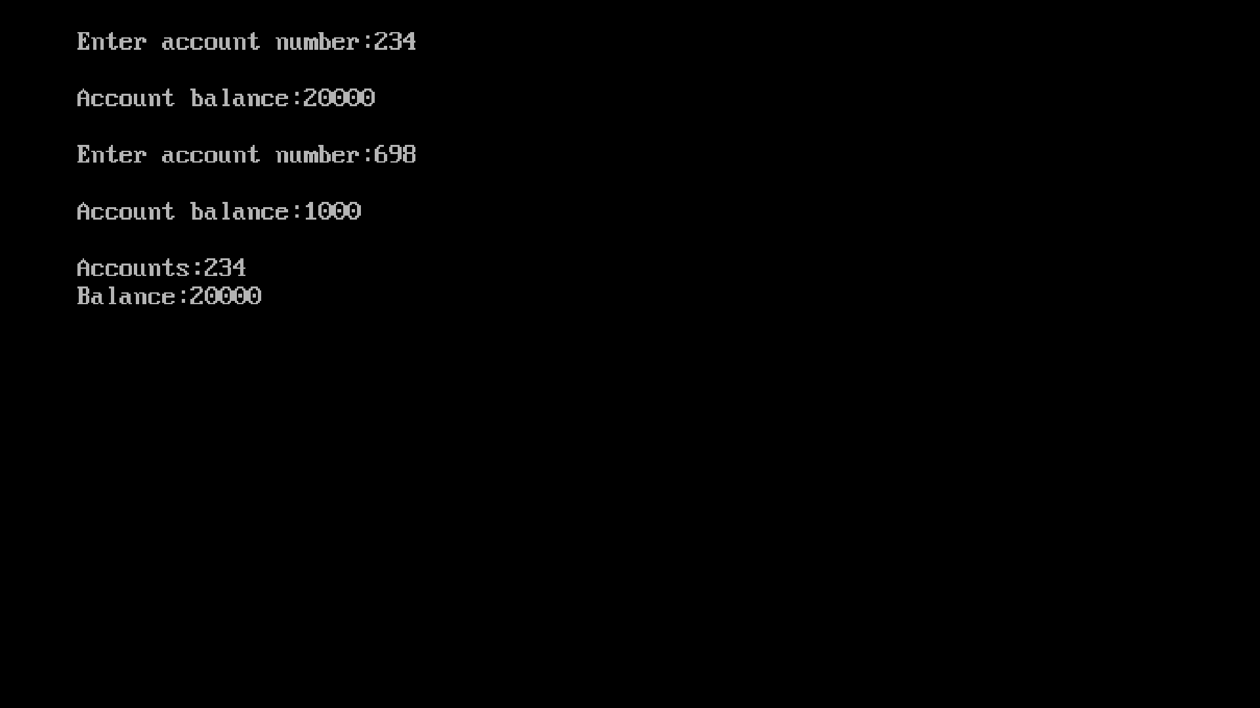

Title:- Write a Program to define a class having data members principal, duration and rate of interest. Declare rate of interest as static member variable calculate the simple interest and display it.
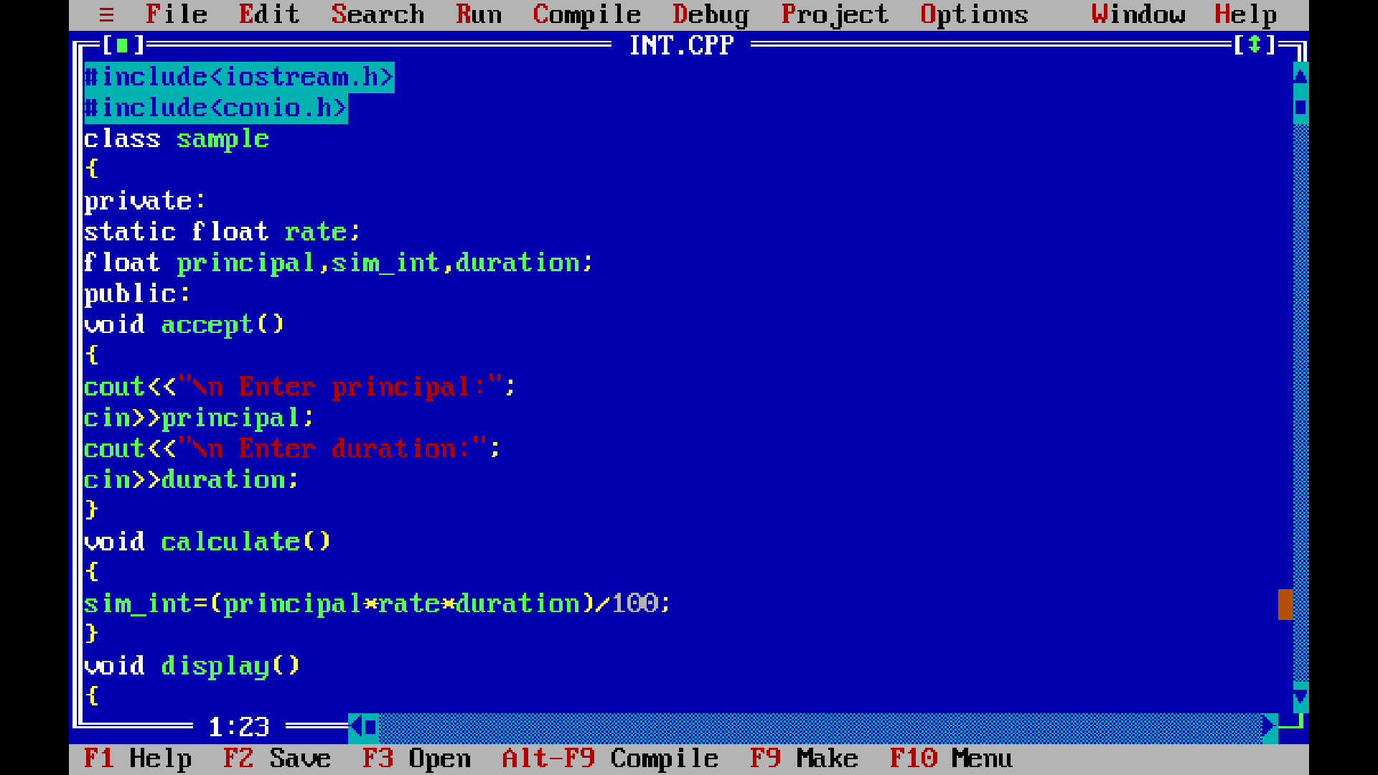
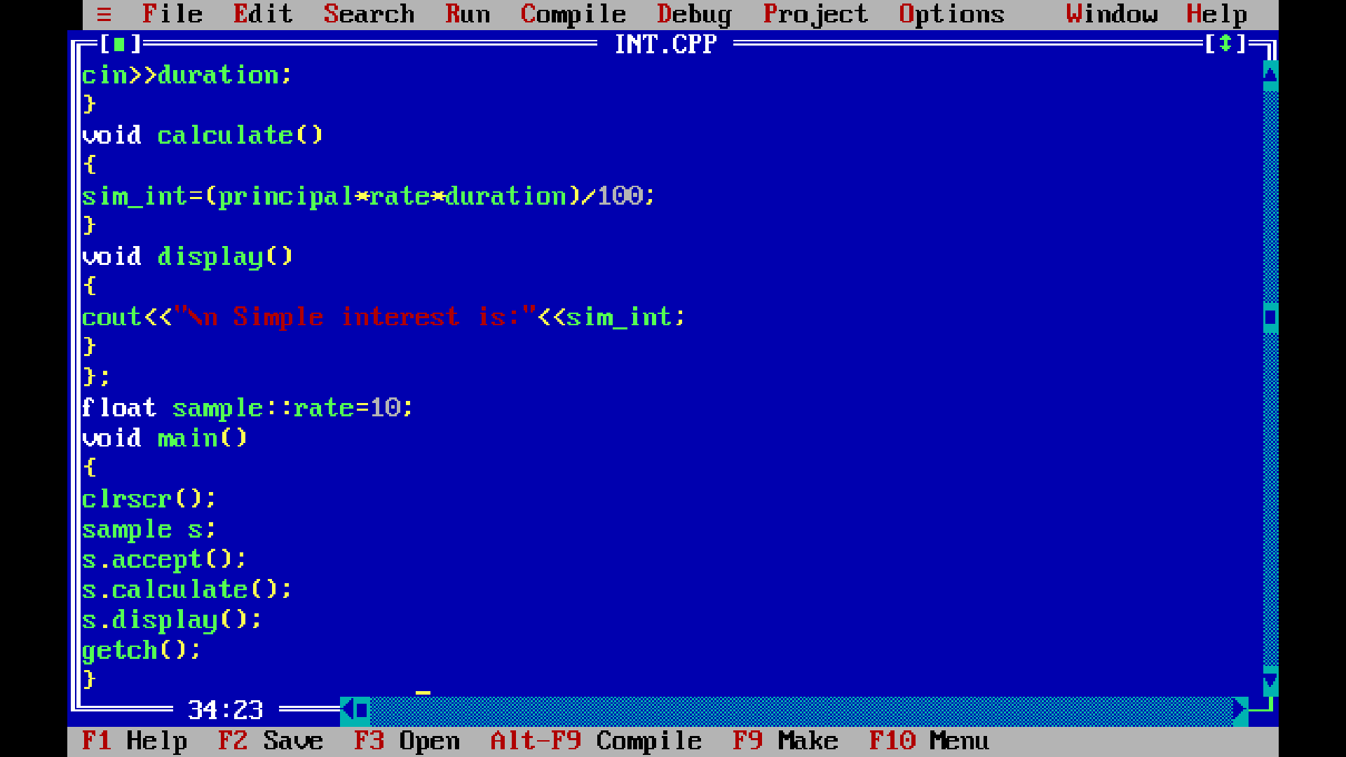

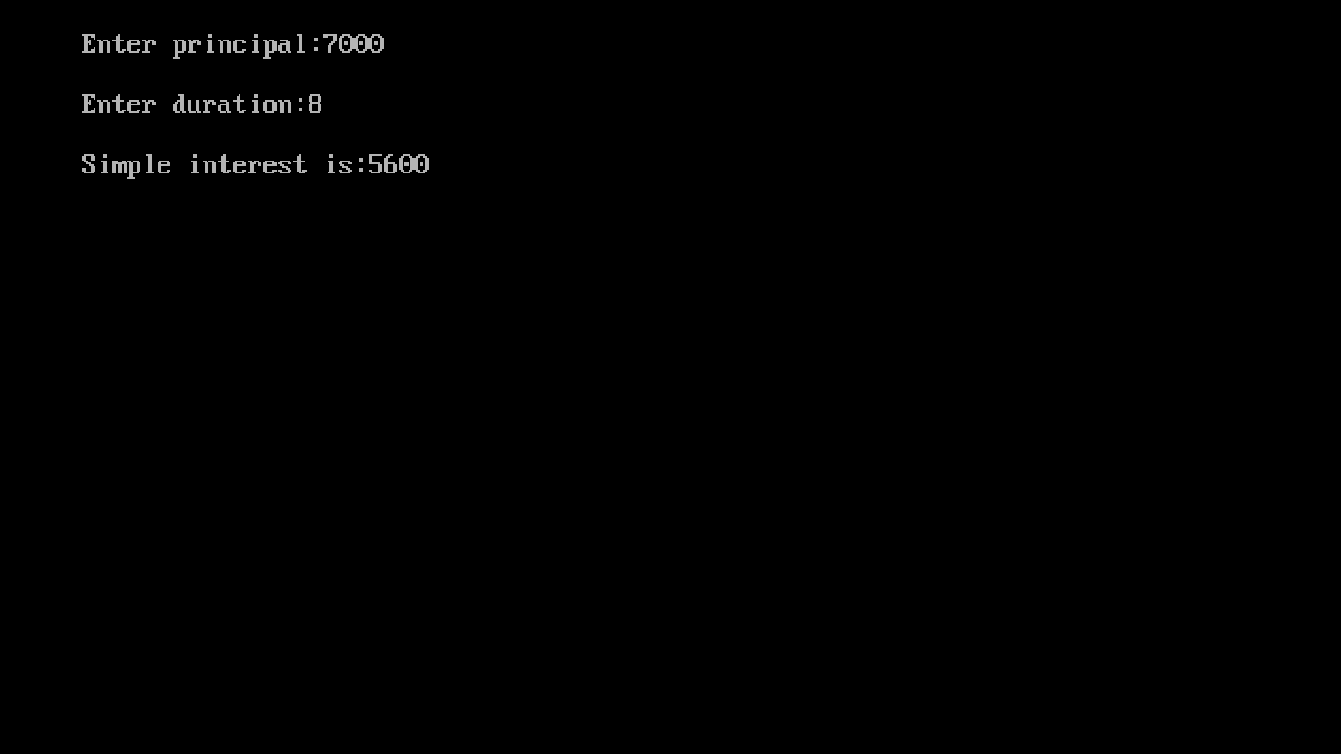

Title:- Write a C++ program to declare a class “Staff” having data members name, basic salary, Da, HRA and calculate gross salary. Accept and display data for one staff
Where DA=74.5% of basic
(i)HRA=30% of basic.
(ii)Gross_salary=basic+HRA+DA
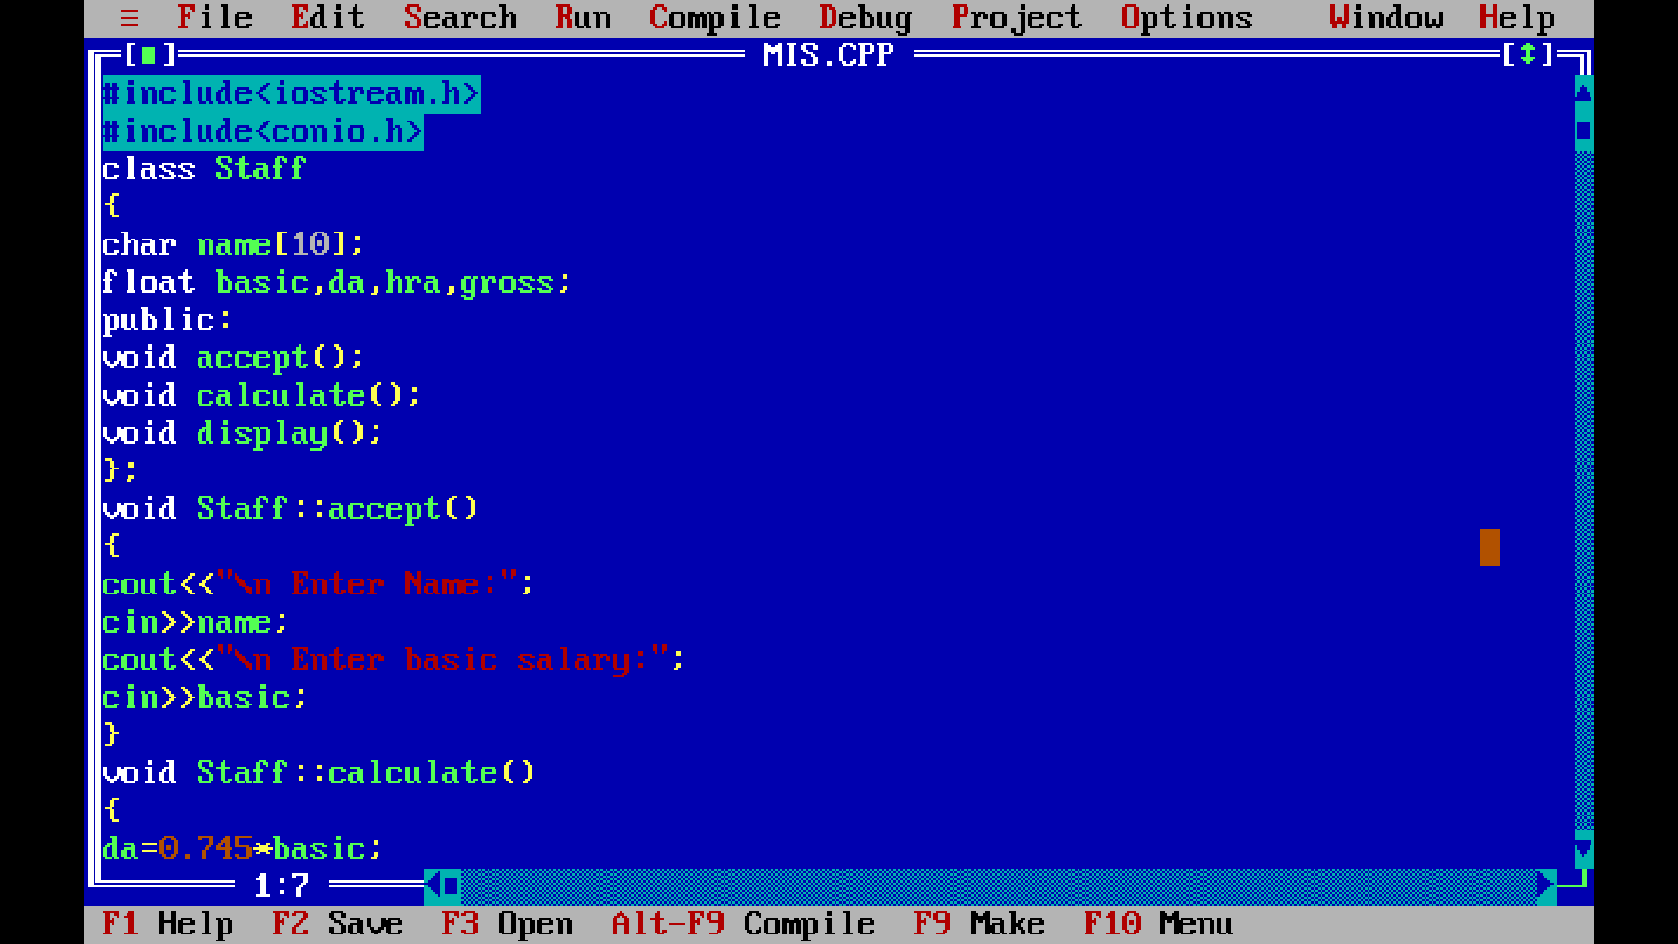

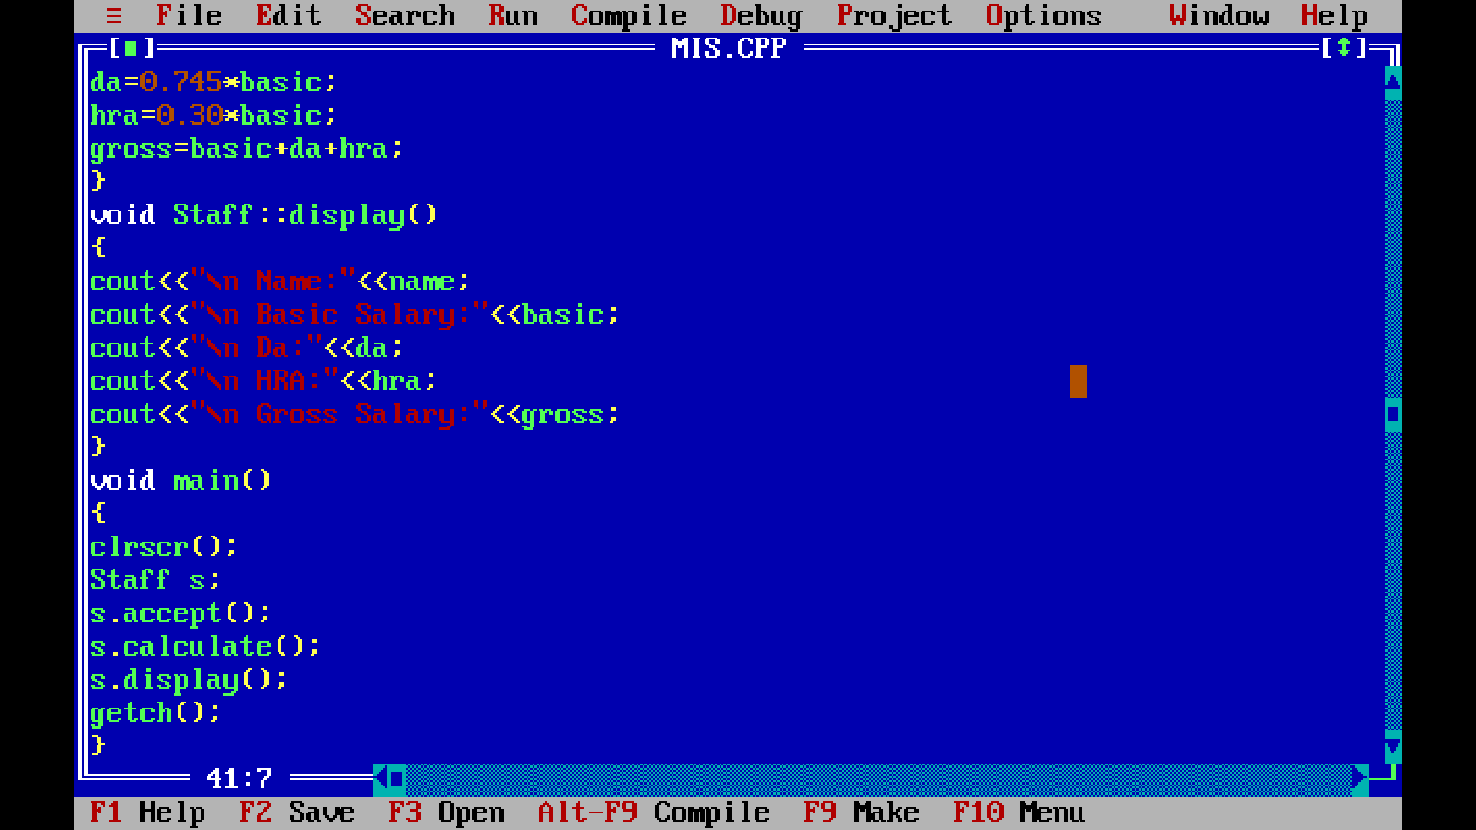

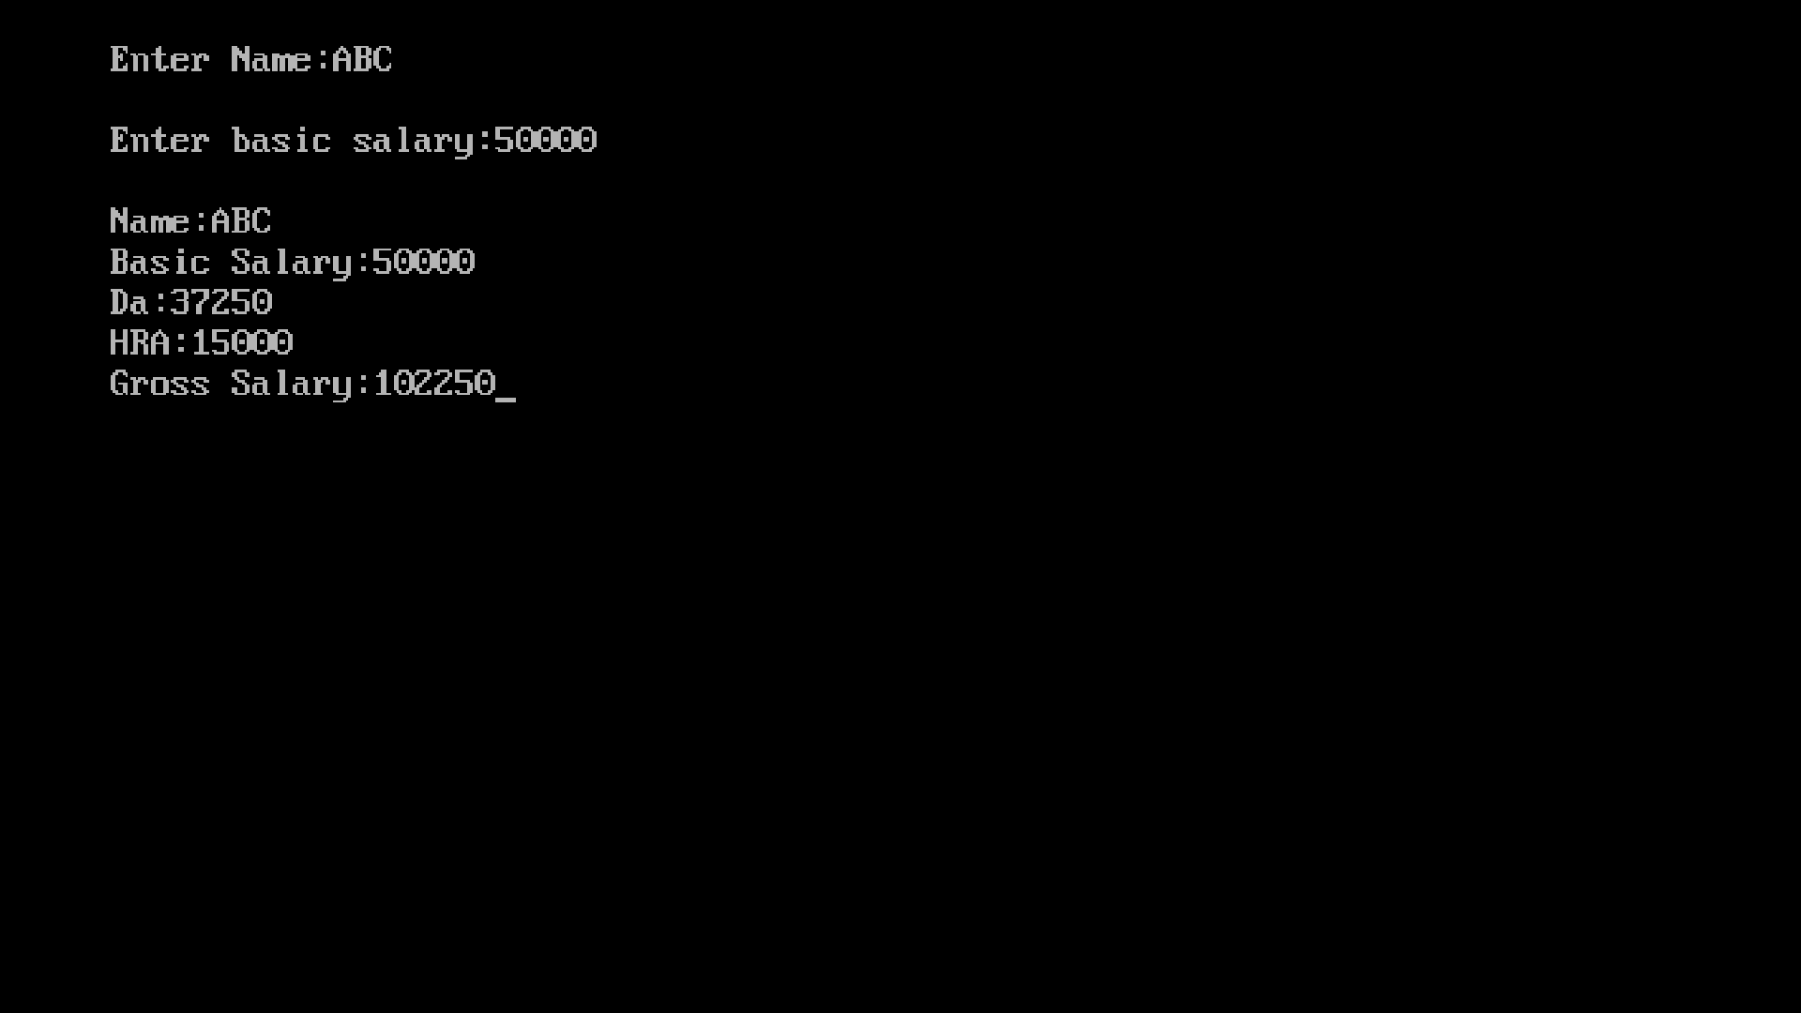

Title:- Write a C++ program to exchange the values of two variables using friend function.

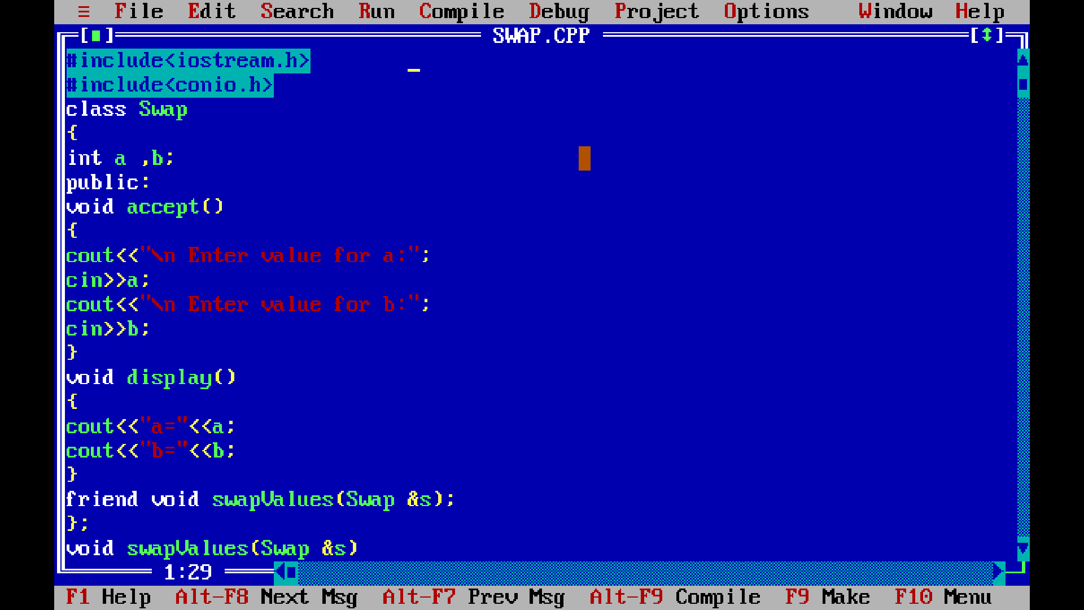

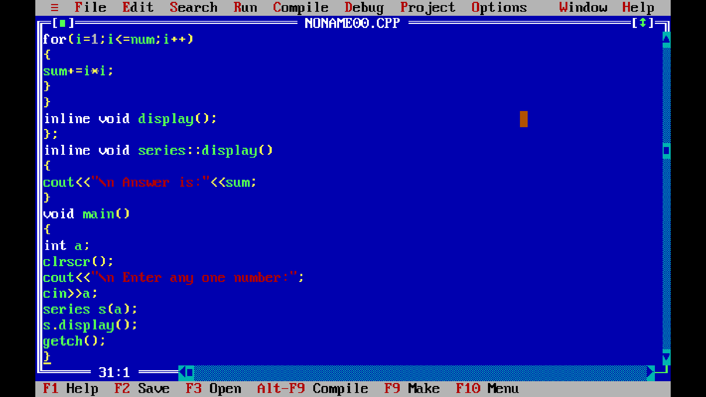
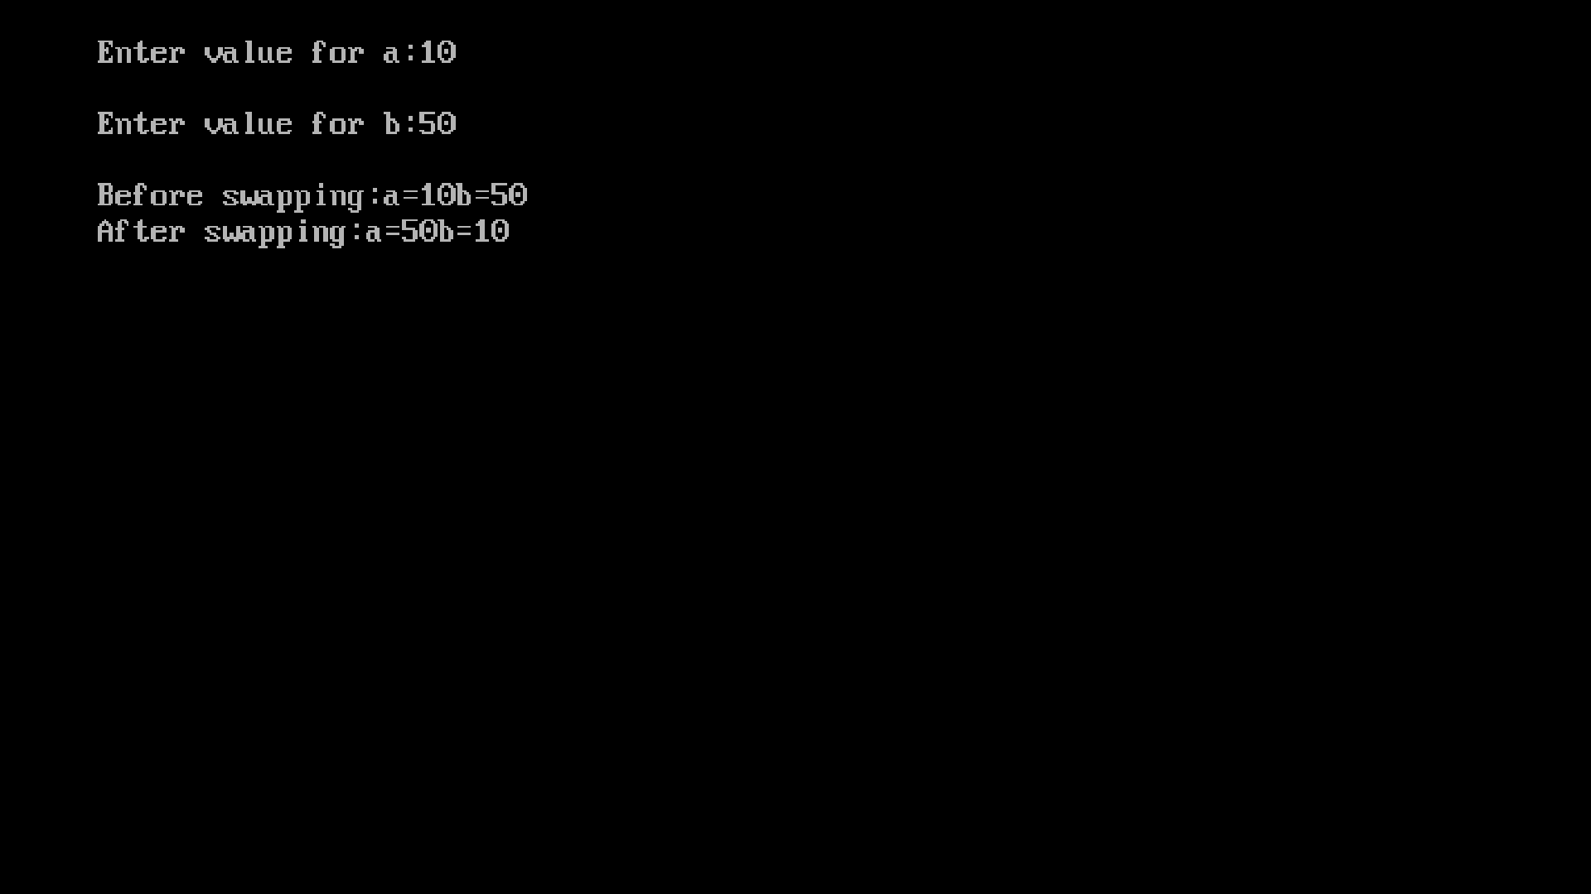
Title:- WAP to create two classes test1 and test2 which stores marks of a stores marks of a student. Read values for class objects and calculate average of two tests using friend function.

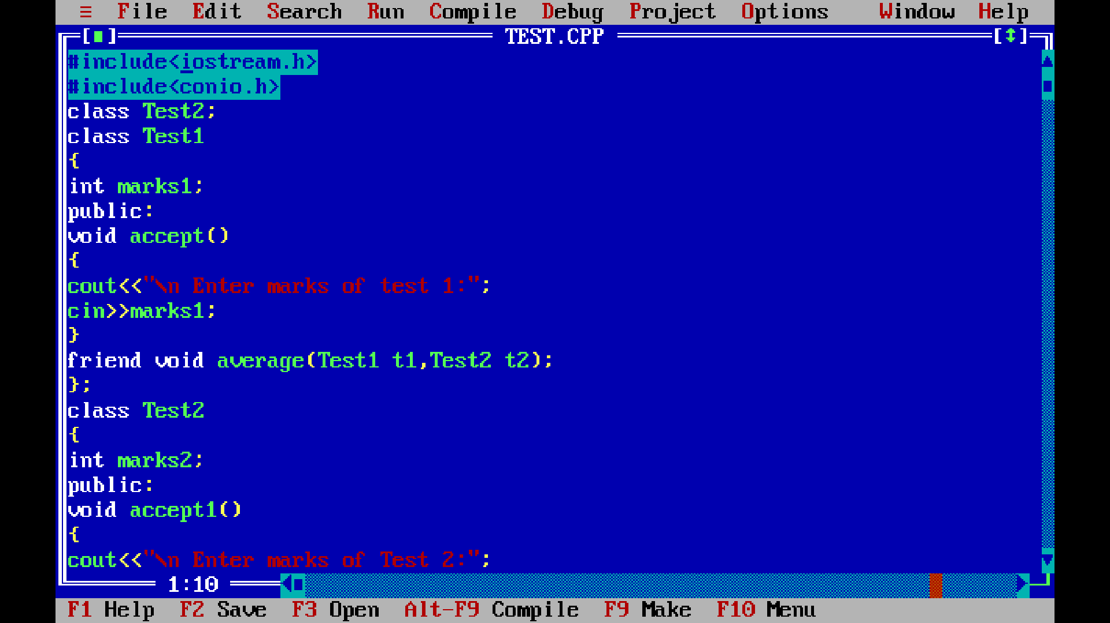

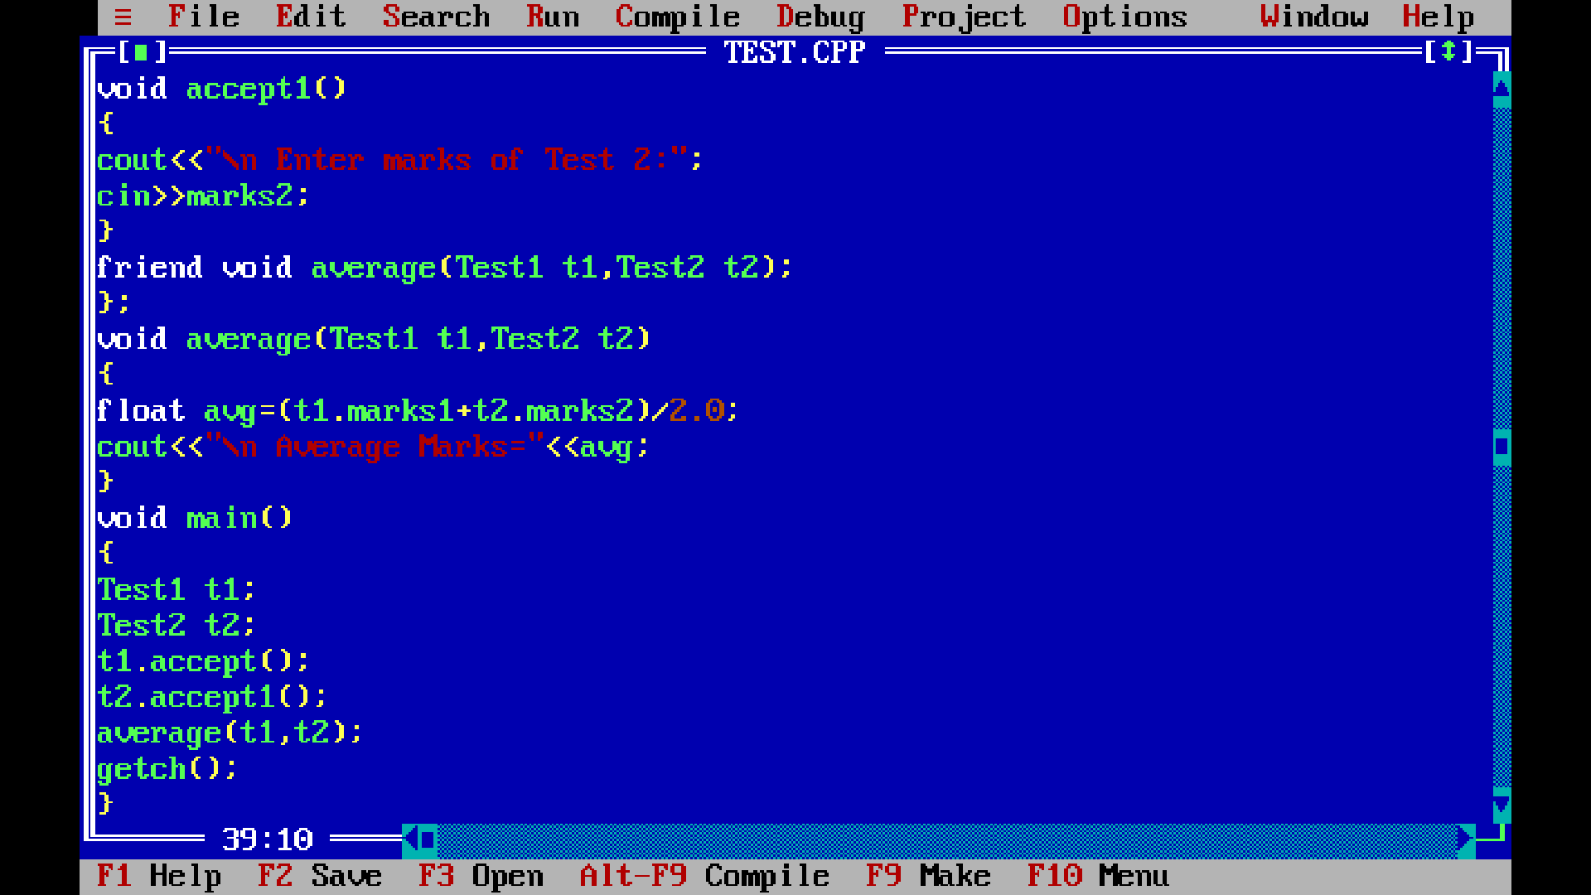
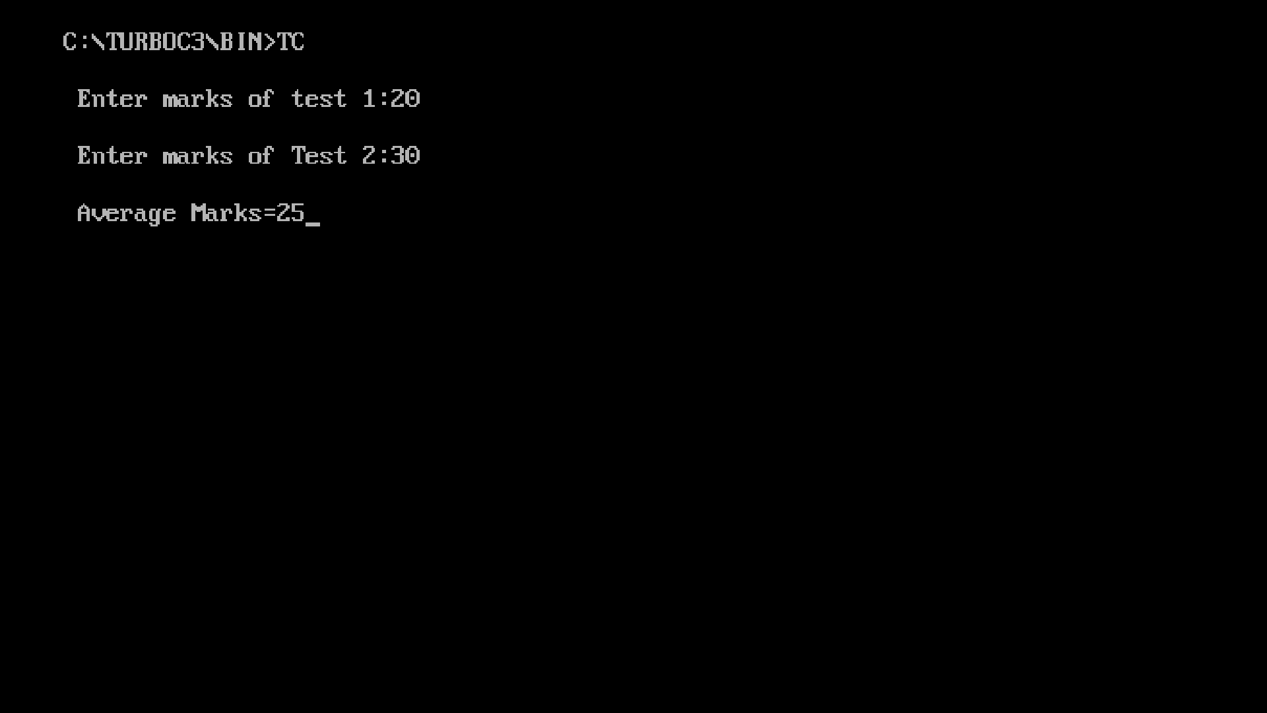
Title:- Define a class student which contain member variables as roll_no, name and course. Write a program using constructor as “Computer Engineering” for course. Accept this data for objects of class and display the data.

